**Report: Collaborative Filtering for Building a Recommendation System**

**1. Introduction**

Collaborative filtering is a popular technique for building recommendation systems. It works by finding similarities between users or items based on past behavior, such as user-item interactions. There are two primary types of collaborative filtering:

* **User-based collaborative filtering**: Recommends items based on the similarity between users.
* **Item-based collaborative filtering**: Recommends items based on the similarity between items.

**2. Data Collection**

For this example, we use a movie rating dataset, such as the **MovieLens** dataset, which contains user ratings for movies.

**3. Collaborative Filtering Process**

The process involves the following steps:

1. **Data Preprocessing**: Organize the data into a user-item matrix.
2. **Similarity Calculation**: Compute the similarity between users or items.
3. **Recommendation Generation**: Based on the calculated similarities, generate recommendations for a given user.

#### ****4. Implementation of Collaborative Filtering****

##### **Step 1: Import Necessary Libraries**

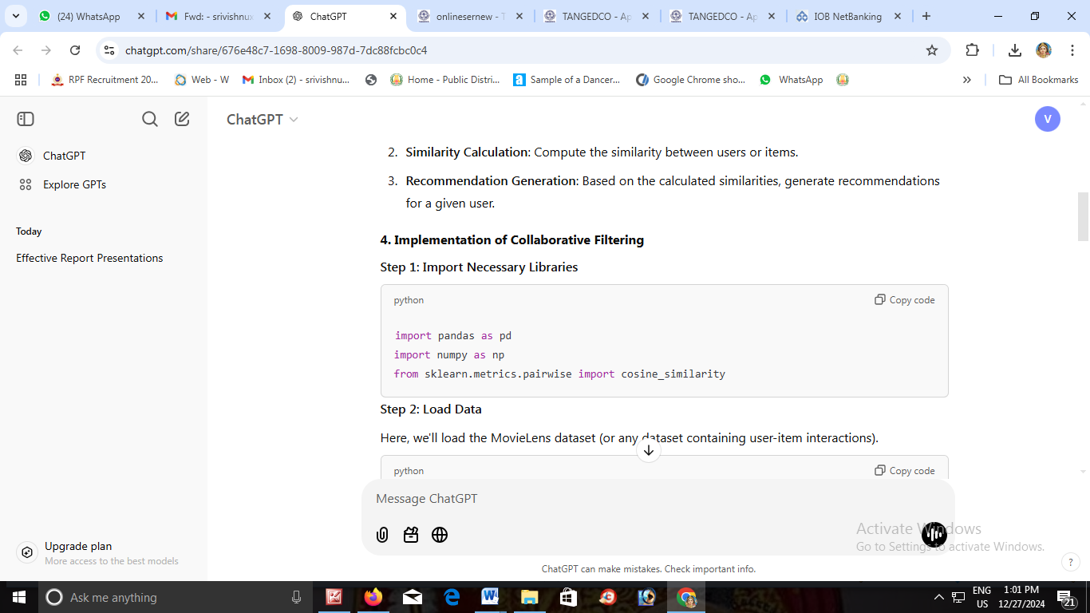

##### **Step 2: Load Data**

Here, we'll load the MovieLens dataset (or any dataset containing user-item interactions).

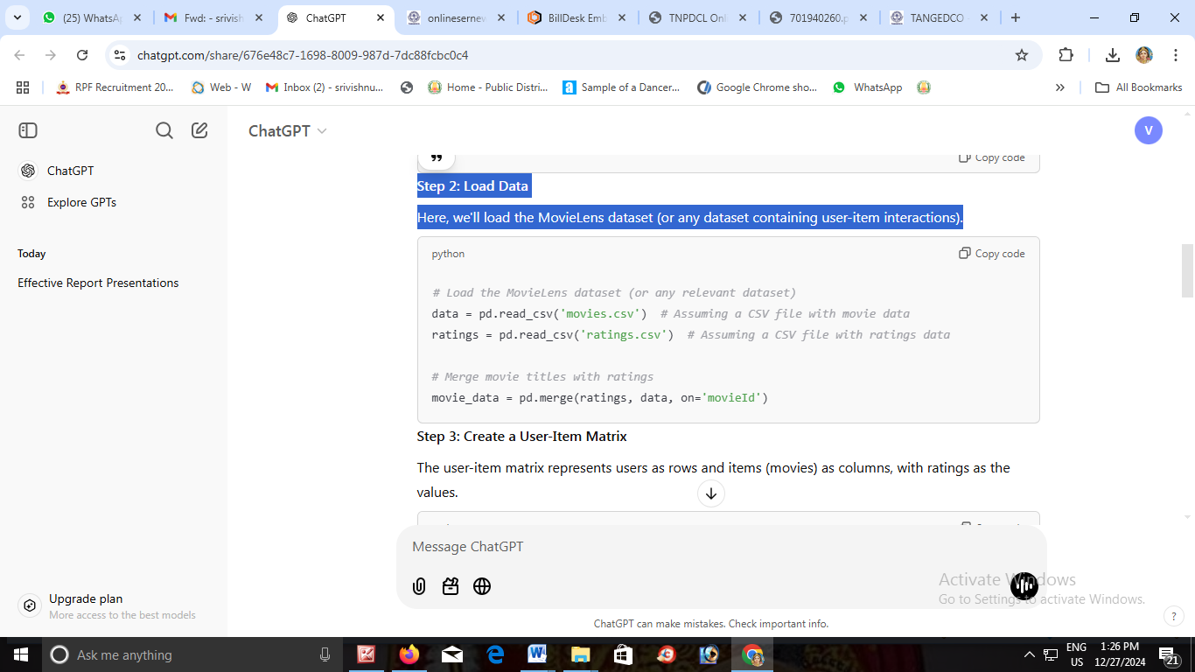

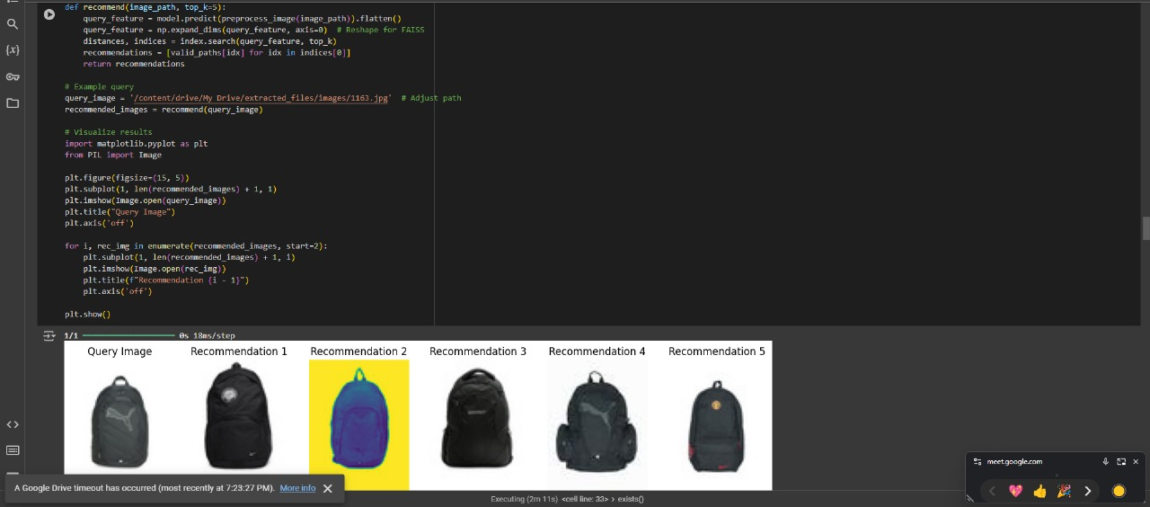

##### **Step 3: Create a User-Item Matrix**

The user-item matrix represents users as rows and items (movies) as columns, with ratings as the values.

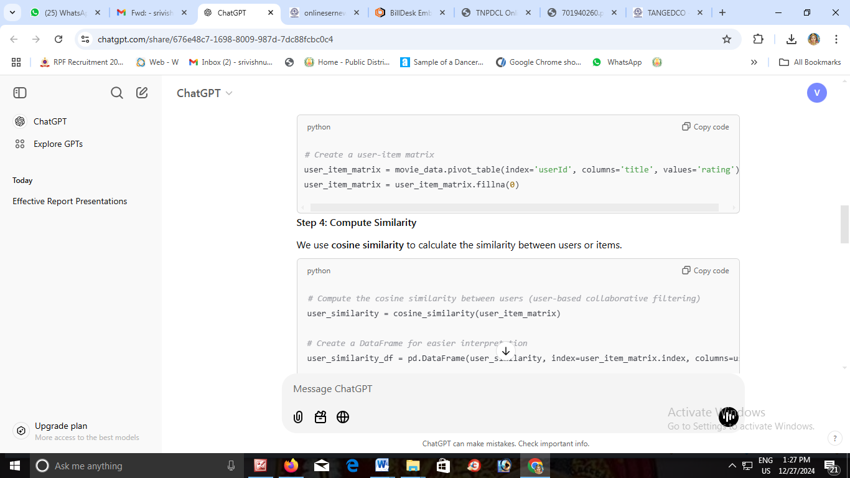

##### C:\Users\Administrator\Downloads\WhatsApp Image 2024-12-27 at 12.55.12 PM.jpeg

##### **Step 4: Compute Similarity**

We use **cosine similarity** to calculate the similarity between users or items.

# Compute the cosine similarity between users (user-based collaborative filtering)

user_similarity = cosine_similarity(user_item_matrix)

# Create a DataFrame for easier interpretation

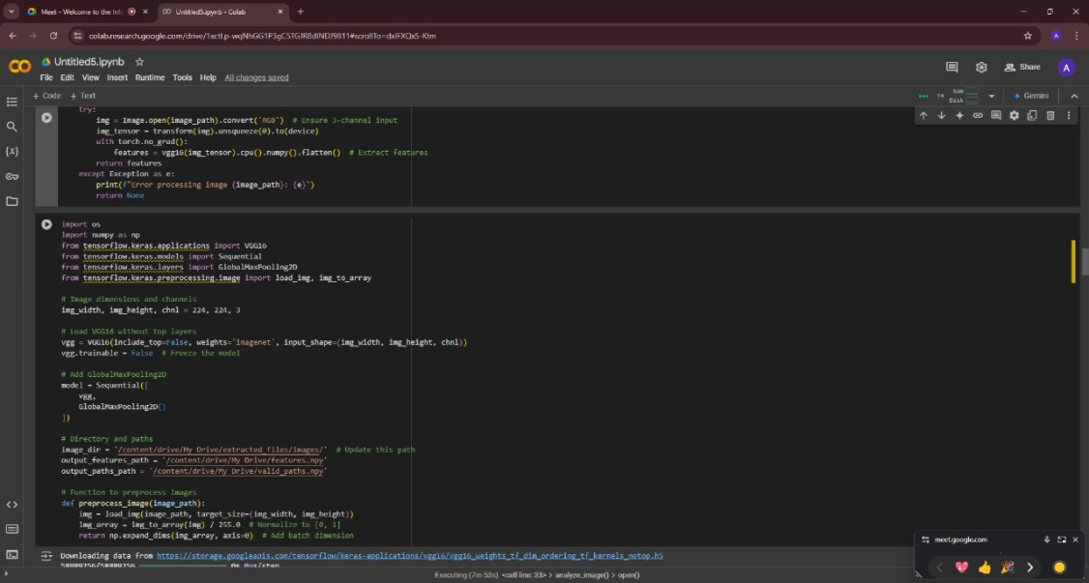user_similarity_df = pd.DataFrame(user_similarity, index=user_item_matrix.index, columns=user_item_matrix.index)

##### **Step 5: Generate Recommendations**

For a given user, we recommend items based on the highest similarity scores with other users.

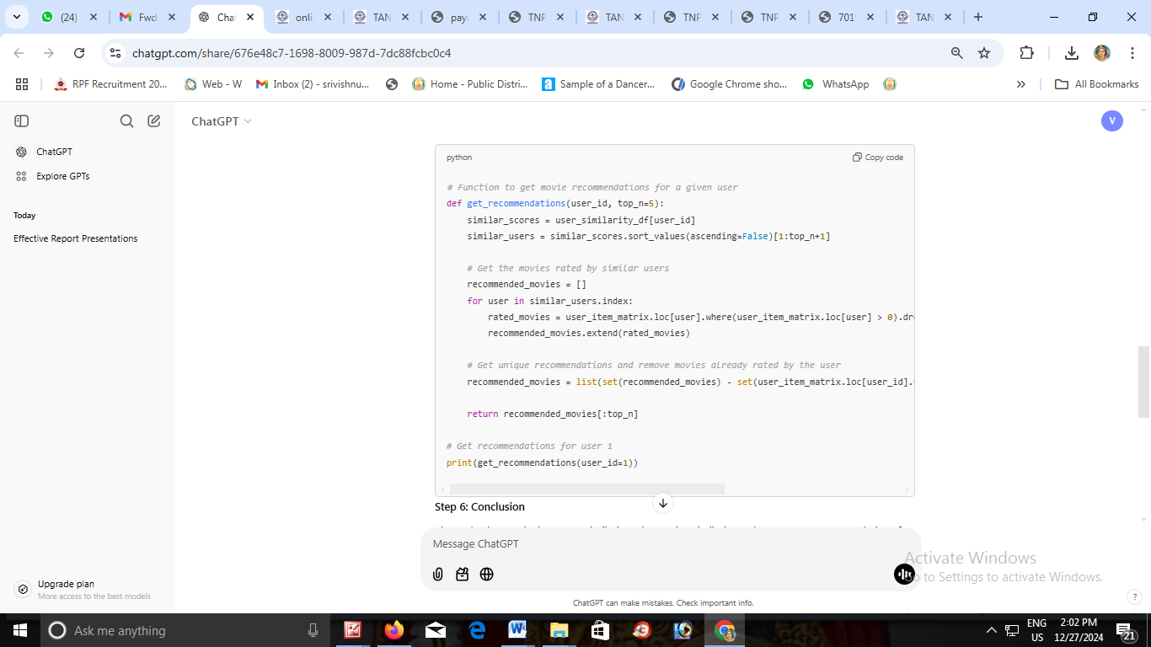

##### C:\Users\Administrator\Downloads\WhatsApp Image 2024-12-27 at 12.55.12 PM (2).jpeg

##### **Step 6: Conclusion**

The code above calculates user similarity using cosine similarity and generates recommendations for a given user based on the ratings of similar users. The get_recommendations function returns the top N movie recommendations for the user.

### ****5. Conclusion****

Collaborative filtering is a powerful method for building recommendation systems. By understanding the similarities between users or items, we can recommend content that a user might like based on the preferences of similar users or items.

This approach can be enhanced with techniques like **Matrix Factorization** (e.g., SVD), and other machine learning-based approaches.